2021

Computer Networks Lab

200994 | BSCYS-III-B

Assignment 1

samiullah iftikhar

Assignment 1

# **Part 1_IP Addressing:**

1. 1*200994%250.1*200994%200.1*200994%150.1*200994%100. = 244.194.144.94

2. 2*200994%250.2*200994%200.2*200994%150.2*200994%100. = 238.188.138.88

3. 3*200994%250.3*200994%200.3*200994%150.3*200994%100. = 232.182.132.82

4. 4*200994%250.4*200994%200.4*200994%150.4*200994%100. = 226.176.126.76

5. 5*200994%250.5*200994%200.5*200994%150.5*200994%100. = 220.170.120.70

|  |  |  |  |  |
| --- | --- | --- | --- | --- |
| **IP Addresses** | **Class** | **Usage** | **Type** | **Status** |
| **244.194.144.94** | E | Public | valid | Not Reserved |
| **238.188.138.88** | E | Public | valid | Not Reserved |
| **232.182.132.82** | E | Public | valid | Not Reserved |
| **226.176.126.76** | D | Public | valid | Not Reserved |
| **220.170.120.70** | D | Public | valid | Not Reserved |

# **Part2_Ping:**

## **244.194.144.94**

## 

## **238.188.138.88**

## 

## **232.182.132.82**

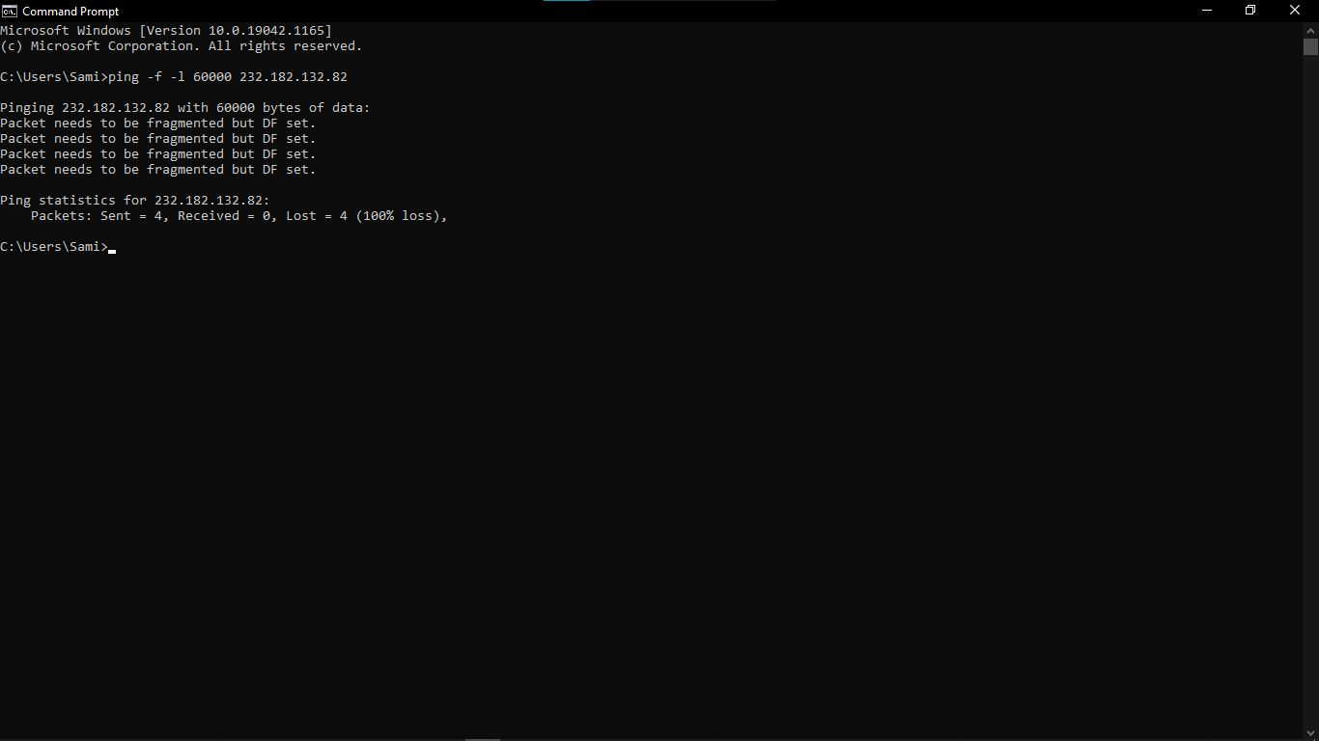

## **226.176.126.76**

## 

## **220 170.120.70**

# 

# **Part3_Tracert:**

## [**www.yahoo.com**](http://www.yahoo.com)

## 

## [**www.facebook.com**](http://www.facebook.com)

## 

## [**www.whatsapp.com**](http://www.whatsapp.com)

## 

## [**www.google.com**](http://www.google.com)

## 

## [**www.instagram.com**](http://www.instagram.com)

